ADEYEMO SHERIFF ADETUNJI

MATRIC NO : 20181702

MCE 320 TERM PAPER REPORT

A report on simulation of an indirect instrument(k-typethermocouple) using Matlab Simulink.

What is a thermocouple?

A thermocouple, also known as a "thermo-electrical thermometer", is an electrical device consisting of two dissimilar electrical conductors forming an electrical junction. A thermocouple produces a temperature-dependent voltage as a result of the Seebeck effect, and this voltage can be interpreted to measure temperature. Thermocouples are widely used as temperature sensors.

Commercial thermocouples are inexpensive, interchangeable, are supplied with standard connectors, and can measure a wide range of temperatures. In contrast to most other methods of temperature measurement, thermocouples are self-powered and require no external form of excitation. The main limitation with thermocouples is accuracy; system errors of less than one degree Celsius (°C) can be difficult to achieve.

Thermocouples are widely used in science and industry. Applications include temperature measurement for kilns, gas turbine exhaust, diesel engines, and other industrial processes. Thermocouples are also used in homes, offices and businesses as the temperature sensors in thermostats, and also as flame sensors in safety devices for gas-powered appliances.

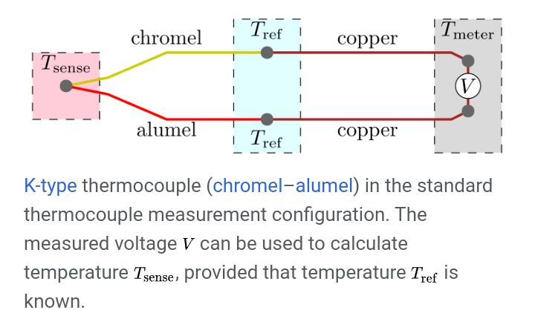

Applications of thermocouples

Thermocouples are suitable for measuring over a large temperature range, from −270 up to 3000 °C (for a short time, in inert atmosphere). Applications include temperature measurement for kilns, gas turbine exhaust, diesel engines, other industrial processes and fog machines. They are less suitable for applications where smaller temperature differences need to be measured with high accuracy, for example the range 0–100 °C with 0.1 °C accuracy. For such applications thermistors, silicon bandgap temperature sensors and resistance thermometers are more suitable.

Brief History

In 1821, the German physicist Thomas Johann Seebeck discovered that a magnetic needle held near a circuit made up of two dissimilar metals got deflected when one of the dissimilar metal junctions was heated. At the time, Seebeck referred to this consequence as thermo-magnetism. The magnetic field he observed was later shown to be due to thermo-electric current. In practical use, the voltage generated at a single junction of two different types of wire is what is of interest as this can be used to measure temperature at very high and low temperatures. The magnitude of the voltage depends on the types of wire being used. Generally, the voltage is in the microvolt range and care must be taken to obtain a usable measurement. Although very little current flows, power can be generated by a single thermocouple junction. Power generation using multiple thermocouples, as in a thermopile, is common.

K-type thermocouple (chromel–alumel) in the standard thermocouple measurement configuration. The measured voltage (V). V can be used to calculate temperature (T_sense). T_sense, provided that temperature (T_ref) .T_ref is known.

The standard configuration for thermocouple usage is shown in the figure. Briefly, the desired temperature T_sense is obtained using three inputs—the characteristic function E(T) of the thermocouple, the measured voltage V, and the reference junctions' temperature Tref. The solution to the equation E(Tsense) = V + E(Tref) yields T_sense. These details are often hidden from the user since the reference junction block (with Tref thermometer), voltmeter, and equation solver are combined into a single product

Seebeck Effect

The Seebeck effect refers to the development of an electromotive force across two points of an electrically conducting material when there is a temperature difference between those two points. Under open-circuit conditions where there is no internal current flow, the gradient of voltage (V) is directly proportional to the gradient in temperature. Where S(T) is a temperature-dependent material property known as the Seebeck coefficient.



where S(T) is a temperature-dependent material property known as the Seebeck coefficient.

The standard measurement configuration shown in the figure shows four temperature regions and thus four voltage contributions:

1. Change from T meter to T ref, in the lower copper wire.
2. Change from T ref to T sense, in the alumel wire.
3. Change from T sense to Tref, in the chromel wire.
4. Change from T ref to T meter, in the upper copper wire.

The first and fourth contributions cancel out exactly, because these regions involve the same temperature change and an identical material. As a result, T meter, does not influence the measured voltage. The second and third contributions do not cancel, as they involve different materials.

The measured voltage turns out to be

V═∫

Where S+ and S- are the Seebeck coefficients of the conductors attached to the positive and the negative terminals of the voltmeter, respectively (chromel and alumel in the figure)

Characteristic function

The thermocouples behavior is captured by a characteristic function E(T), which only needs to be consulted at two arguments:

V

In terms of the Seebeck coefficients, the characteristic function is defined by

E

The constant of integration in this indefinite integral has no significance but is conventionally chosen such that E(0°C)=0  
  
   
TYPES OF THERMOCOUPLE

There are different types of thermocouples depending on the type of dissimilar metal used and they include:  
1. Nickel-alloy thermocouples

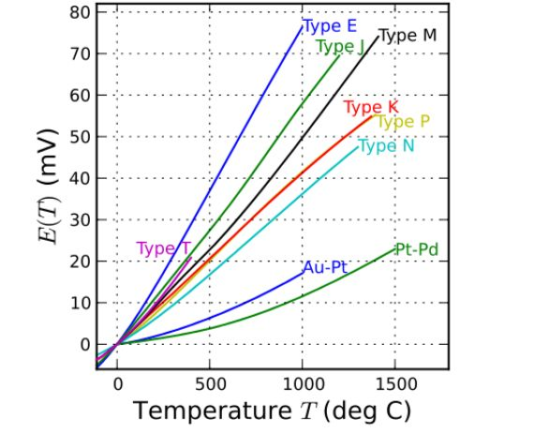

Type E

Type E (chromel–constantan) has a high output (68 µV/°C), which makes it well suited to cryogenic use. Additionally, it is non-magnetic. Wide range is −270 °C to +740 °C and narrow range is −110 °C to +140 °C.

Type J

Type J (iron–constantan) has a more restricted range (−40 °C to +750 °C) than type K but higher sensitivity of about 50 µV/°C.[2] The Curie point of the iron (770 °C)[9] causes a smooth change in the characteristic, which determines the upper temperature limit. Note, the European/German Type L is a variant of the type J, with a different specification for the EMF output.

Type K

Type K (chromel–alumel) is the most common thermocouple with a sensitivity of approximately 41 µV/°C. It is inexpensive, and a wide variety of probes are available in its −200 °C to +1350 °C (−330 °F to +2460 °F) range. Type K was specified at a time when metallurgy was less advanced than it is today, and consequently characteristics may vary considerably between samples. One of the constituent metals, nickel, is magnetic; a characteristic of thermocouples made with magnetic material is that they undergo a deviation in output when the material reaches its Curie point, which occurs for type K thermocouples at around 185 °C.

Type M

Type M (82%Ni/18%Mo–99.2%Ni/0.8%Co, by weight) are used in vacuum furnaces for the same reasons as with type C (described below). Upper temperature is limited to 1400 °C. It is less commonly used than other types.

Type N

Type N (Nicrosil–Nisil) thermocouples are suitable for use between −270 °C and +1300 °C, owing to its stability and oxidation resistance. Sensitivity is about 39 µV/°C at 900 °C, slightly lower compared to type K.

Type T

Type T (copper–constantan) thermocouples are suited for measurements in the −200 to 350 °C range. Often used as a differential measurement, since only copper wire touches the probes. Since both conductors are non-magnetic, there is no Curie point and thus no abrupt change in characteristics. Type-T thermocouples have a sensitivity of about 43 µV/°C. Note that copper has a much higher thermal conductivity than the alloys generally used in thermocouple constructions, and so it is necessary to exercise extra care with thermally anchoring type-T thermocouples. A similar composition is found in the obsolete Type U in the German specification DIN 43712:1985-01.

2. Platinum/rhodium-alloy thermocouples

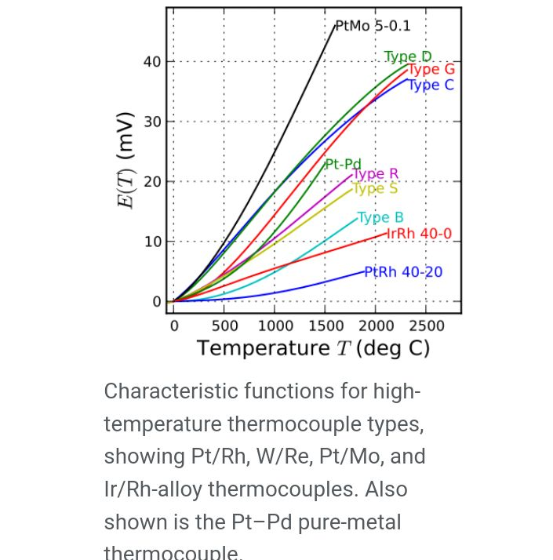

Type B

Type B (70%Pt/30%Rh–94%Pt/6%Rh, by weight) thermocouples are suited for use at up to 1800 °C. Type-B thermocouples produce the same output at 0 °C and 42 °C, limiting their use below about 50 °C. The emf function has a minimum around 21 °C, meaning that cold-junction compensation is easily performed, since the compensation voltage is essentially a constant for a reference at typical room temperatures.

Type R

Type R (87%Pt/13%Rh–Pt, by weight) thermocouples are used 0 to 1600 °C. Type R Thermocouples are quite stable and capable of long operating life when used in clean, favorable conditions. When used above 1100 °C ( 2000 °F), these thermocouples must be protected from exposure to metallic and non-metallic vapors. Type R is not suitable for direct insertion into metallic protecting tubes. Long term high temperature exposure causes grain growth which can lead to mechanical failure and a negative calibration drift caused by Rhodium diffusion to pure platinum leg as well as from Rhodium volatilization. This type has the same uses as type S, but is not interchangeable with it.

Type S

Type S (90%Pt/10%Rh–Pt, by weight) thermocouples, similar to type R, are used up to 1600 °C. Before the introduction of the International Temperature Scale of 1990 (ITS-90), precision type-S thermocouples were used as the practical standard thermometers for the range of 630 °C to 1064 °C, based on an interpolation between the freezing points of antimony, silver, and gold. Starting with ITS-90, platinum resistance thermometers have taken over this range as standard thermometers.

3. Tungsten/rhenium-alloy thermocouples

Type C

(95%W/5%Re–74%W/26%Re, by weight) maximum temperature will be measured by type-c thermocouple is 2329 ℃.

Type D

(97%W/3%Re–75%W/25%Re, by weight)

Type G

(W–74%W/26%Re, by weight)

4. Others

Chromel–gold/iron-alloy thermocouples

In these thermocouples (chromel–gold/iron alloy), the negative wire is gold with a small fraction (0.03–0.15 atom percent) of iron. The impure gold wire gives the thermocouple a high sensitivity at low temperatures (compared to other thermocouples at that temperature), whereas the chromel wire maintains the sensitivity near room temperature. It can be used for cryogenic applications (1.2–300 K and even up to 600 K). Both the sensitivity and the temperature range depend on the iron concentration. The sensitivity is typically around 15 µV/K at low temperatures, and the lowest usable temperature varies between 1.2 and 4.2 K and so on.

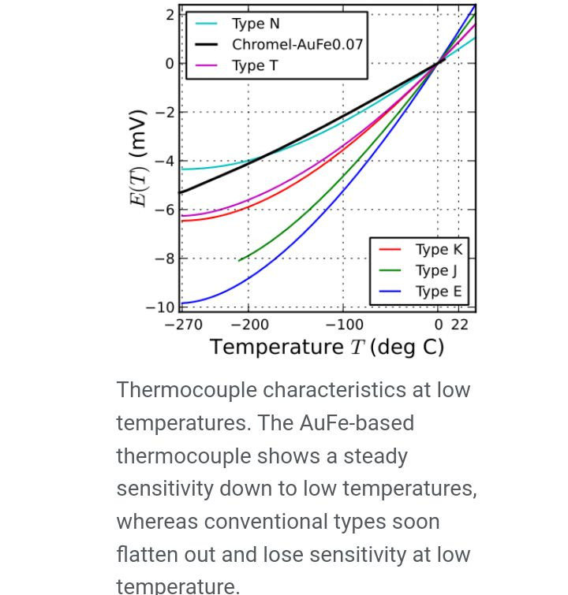

Simulation of a K-type thermocouple

To simulate a K-type thermocouple you should do the following:

1. Open the Matlab software.

2. Type fx>>>simulinks, the software will display a new page with lots of options,select a Blank Model.

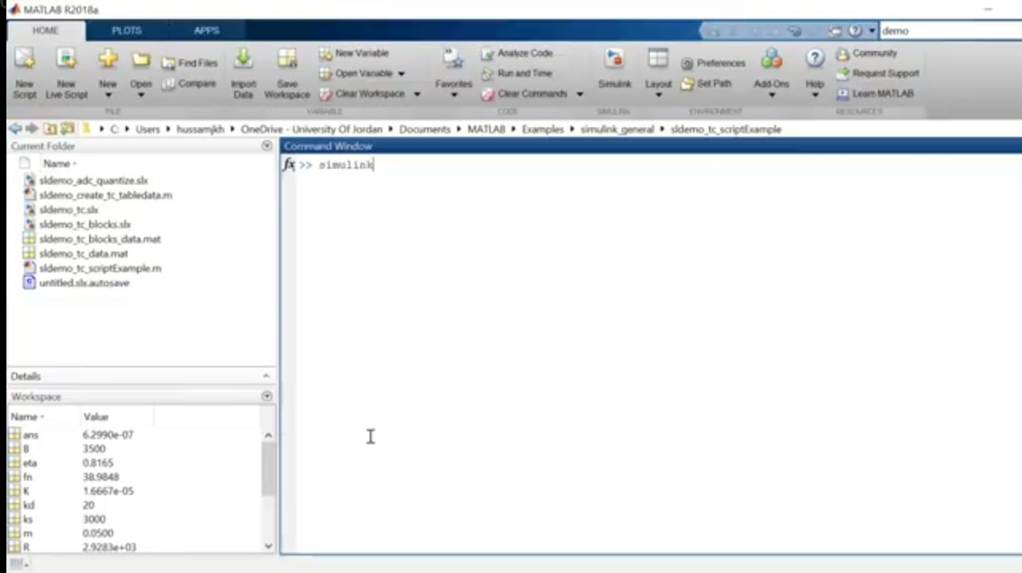

3. Then select libraries on the Blank Model and on the libraries select sensor.

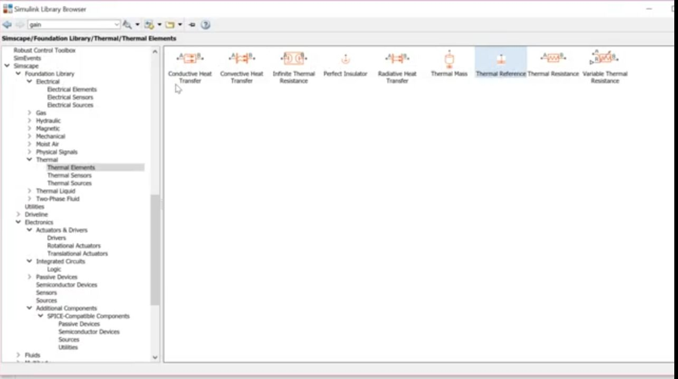

4. On the list of sensors select a thermocouple

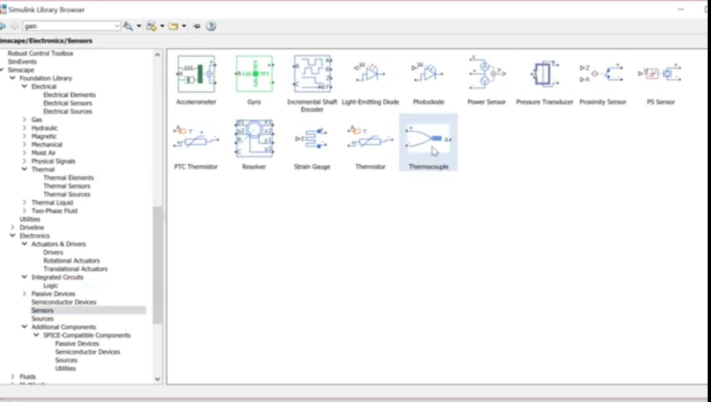

5. Chose the thermocouple type (in this case type k)

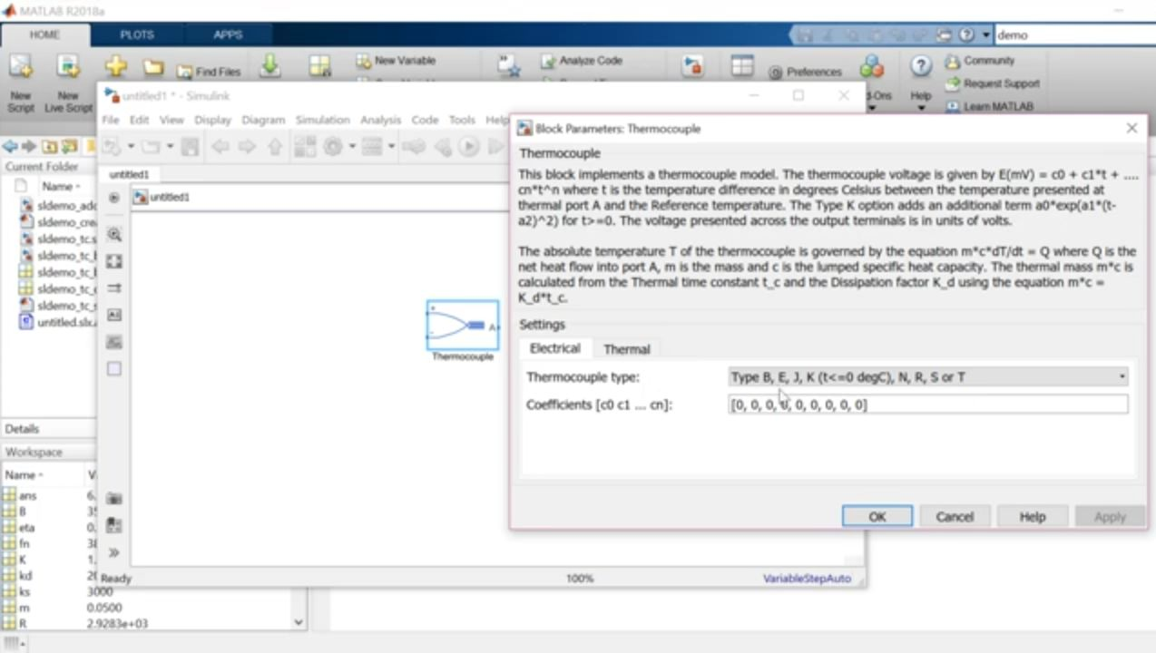

6. The Matlab software will need a reference table,some polynomials and thermocouple coefficients(all are in the subsequent pages) to simulate the instrument .

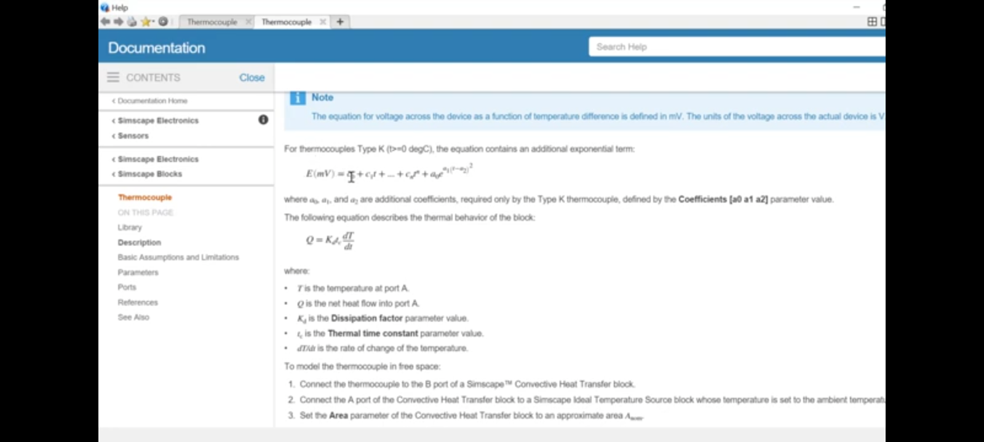

7. Connect the instrument as shown below.

